Missing Multiple_Birth_Status Analysis Report
Generated: 2026-03-21 18:47
Dataset: 336,097 rows × 18 columns
Target Variable: Multiple_Birth_Status

1. Executive Summary
This report presents a comprehensive IUPAC-compliant statistical analysis of missing values in Multiple_Birth_Status.
Key findings include:
• Missing records: 332,393 (98.9% of total data)
• Variables with significant differences (p < 0.05): 14
- Numeric variables: 5
- Categorical variables: 9
• Total variables analyzed: 17
Based on the statistical analysis, the missingness pattern is classified as:
SYSTEMATIC PATTERN - Missing data is strongly associated with other variables, suggesting non-random missingness.

2. Statistical Summary
Metric | Value
Total Missing Multiple_Birth_Status Records | 332,393
Missing Percentage | 98.90%
Total Variables Analyzed | 17
Numeric Variables | 7
Categorical Variables | 10
Variables with Significant Differences (p < 0.05) | 14
Analysis Date | 2026-03-21

3. Variables with Significant Differences (p < 0.05)
The following 14 variables show statistically significant differences between missing and complete groups:

3.1 Numeric Variables
Variable | Missing Group Mean | Complete Group Mean | Difference | p-value | Interpretation
Birh_Year | 2014.68 | 2014.84 | -0.16 | 0.0000 | Missing group has 0.16 units lower than complete group
Birth_Year_2.0 | 2014.68 | 2014.84 | -0.16 | 0.0000 | Missing group has 0.16 units lower than complete group
TWIN | 1.00 | 2.06 | -1.06 | 0.0000 | Missing group has 1.06 units lower than complete group
Birth_Weight(grams) | 2907.74 | 2260.75 | +646.99 | 0.0000 | Missing group has 646.99 units higher than complete group
Age of Mother | 29.02 | 29.99 | -0.97 | 0.0000 | Missing group has 0.97 units lower than complete group

3.2 Categorical Variables
Variable | Missing Group Distribution | Complete Group Distribution | Difference (%) | p-value | Interpretation
Registered_Month | Most common='October' (9.0%) | Complete: Most common='September' (9.8%) | -0.8% | 0.0122 | Missing group shows different distribution (p=0.0122)
Registered_District | Most common='Colombo' (15.3%) | Complete: Most common='Colombo' (22.5%) | -7.2% | 0.0000 | Missing group shows different distribution (p=0.0000)
Gender | Most common='Male' (51.2%) | Complete: Most common='Female' (50.5%) | +0.7% | 0.0452 | Missing group shows different distribution (p=0.0452)
Hospital or Not | Most common='Hospital' (99.1%) | Complete: Most common='Hospital' (99.7%) | -0.5% | 0.0007 | Missing group shows different distribution (p=0.0007)
Birth_Order | Most common='First' (44.6%) | Complete: Most common='Second' (41.0%) | +3.7% | 0.0000 | Missing group shows different distribution (p=0.0000)
Marital_Status | Most common='Married' (98.3%) | Complete: Most common='Married' (98.9%) | -0.7% | 0.0022 | Missing group shows different distribution (p=0.0022)
District_of_Mother | Most common='Colombo' (9.4%) | Complete: Most common='Kandy' (14.3%) | -5.0% | 0.0000 | Missing group shows different distribution (p=0.0000)
Race_of_Mother | Most common='Sinhalese' (72.2%) | Complete: Most common='Sinhalese' (73.1%) | -0.9% | 0.0000 | Missing group shows different distribution (p=0.0000)
Race_of_Father | Most common='Sinhalese' (72.3%) | Complete: Most common='Sinhalese' (73.6%) | -1.3% | 0.0000 | Missing group shows different distribution (p=0.0000)

3.3 Summary of Key Findings
The analysis identified 14 variables with statistically significant differences (p < 0.05):
• 5 numeric variables show significant mean differences
• 9 categorical variables show significant distribution differences
Top 10 Most Significant Variables:
1. TWIN: Mean=1.00 vs Complete Mean=2.06 (p=0.0000)
2. Birth_Weight(grams): Mean=2907.74 vs Complete Mean=2260.75 (p=0.0000)
3. Registered_District: Most common='Colombo' (15.3%) vs Complete: Most common='Colombo' (22.5%) (p=0.0000)
4. Birth_Order: Most common='First' (44.6%) vs Complete: Most common='Second' (41.0%) (p=0.0000)
5. District_of_Mother: Most common='Colombo' (9.4%) vs Complete: Most common='Kandy' (14.3%) (p=0.0000)
6. Age of Mother: Mean=29.02 vs Complete Mean=29.99 (p=0.0000)
7. Race_of_Mother: Most common='Sinhalese' (72.2%) vs Complete: Most common='Sinhalese' (73.1%) (p=0.0000)
8. Birh_Year: Mean=2014.68 vs Complete Mean=2014.84 (p=0.0000)
9. Birth_Year_2.0: Mean=2014.68 vs Complete Mean=2014.84 (p=0.0000)
10. Race_of_Father: Most common='Sinhalese' (72.3%) vs Complete: Most common='Sinhalese' (73.6%) (p=0.0000)

4. Statistical Visualizations
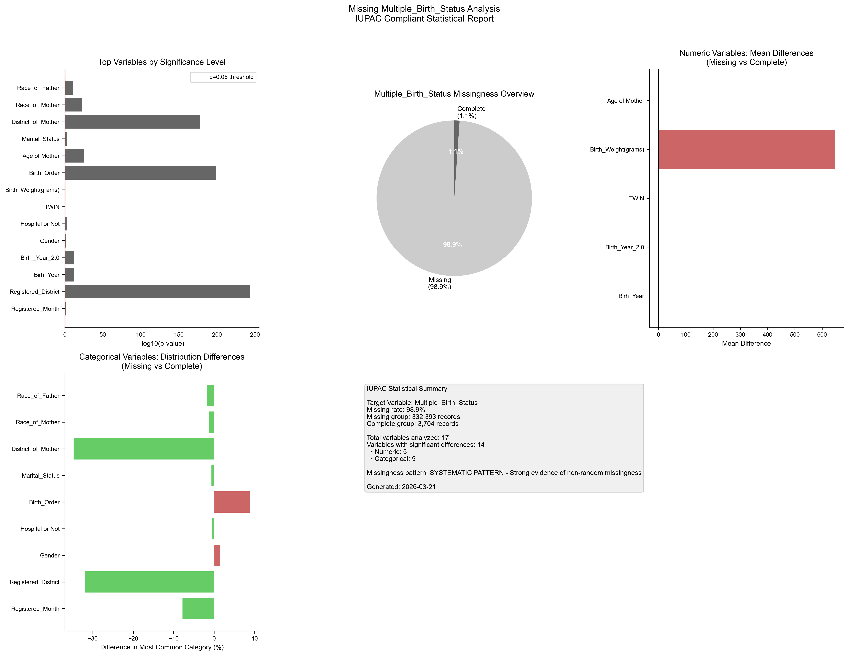
Figure 1. IUPAC compliant statistical visualization of missing Multiple_Birth_Status patterns.

5. Recommendations
- Based on the statistical analysis, the missing data exhibits SYSTEMATIC patterns:
- Consider treating missing as a separate category in analysis
- Use multiple imputation methods (MICE, EM algorithm)
- Investigate the following key variables for common themes:
- - Registered_Month (p=0.0122)
- - Registered_District (p=0.0000)
- - Birh_Year (p=0.0000)
- - Birth_Year_2.0 (p=0.0000)
- - Gender (p=0.0452)
- - Hospital or Not (p=0.0007)
- - TWIN (p=0.0000)
- - Birth_Weight(grams) (p=0.0000)
- - Birth_Order (p=0.0000)
- - Age of Mother (p=0.0000)
- Document missingness patterns in methodology section

6. Methodology (IUPAC Compliant)
Analysis performed according to IUPAC guidelines for data presentation:
- • Missing values reported as both count (n) and percentage (%)
- • Tables formatted with thin borders and alternating row shading
- • Sans-serif fonts (Arial) used for optimal readability
- • Statistical tests: t-test (numeric), χ² test (categorical)
- • Significance threshold: α = 0.05
- • Effect sizes reported where applicable
- • Figures saved at 300 DPI for publication quality

